North Carolina
Fire Marshals’
Association
By-Laws

ARTICLE I – ORGANIZATION

- Name
The organization shall be known as: “THE NORTH CAROLINA FIRE MARSHALS’ ASSOCIATION, INC.”

- Seal
The North Carolina Fire Marshals’ Association seal shall be used at the direction of the Officers. Changes to the seal shall be accepted by a majority of the Officers and the majority of the members in attendance of a single meeting. The Official Seal, as adopted January 31, 2020 is listed in Appendix B.

- Affiliation
The Officers of the North Carolina Fire Marshals’ Association shall have the authority to determine those professional associations with which the Association shall affiliate.

ARTICLE II – OBJECTIVES

- To coordinate the efforts of its members in the fields of Fire Prevention, Fire Safety Education, Fire Protection, Investigation and Suppression of Arson and Unlawful Burnings; and by doing so, endeavor to provide a more efficient and uniform Fire Prevention Program in North Carolina.

- To distribute to its members information pertaining to Fire Prevention, Fire Safety Education, Fire Protection, and Investigation as may be available; and to assist its members in the solution of any problems which may arise in these fields.

- To, at all times, assist and cooperate with such Associations and Organizations, Industries, Government Agencies, or Departments which share our common interest in the protection of lives and property from fire.

- To actively promote participation from all stakeholders to ensure community based risk reduction assessments, plans and services are effectively implemented.

ARTICLE III – MEMBERSHIP

- Active Member: Any legally designated official of a county, municipality, township, fire district, or other person who is authorized and obligated by public law, ordinance, or lawful agreement with the prevention of fire through property inspection, enforcement of fire laws and regulations, public education, and who may also be charged with the duty of investigating the origin and cause of fires in North Carolina.

- Active Life Member: Any past active member of the Association who has retired from active fire service and who has served 20 years as an active member or who has served as an officer of the Association shall be eligible for Active Life Membership upon the recommendation and approval of the Board.

Any past active member of the Association who has retired from active fire service and who has rendered outstanding service to the Association, or has distinguished him/herself by outstanding service in the fields of fire protection, fire prevention, public fire safety education, or fire investigation and by exceptional service to the Association, who is interested in the protection of life and property from fire shall be eligible for Active Life Membership upon the recommendation and approval of the Board.

- Associate Member: Those persons, other than Active Members, interested or involved in the prevention of fire in North Carolina. Associate Members shall enjoy the privileges of membership except that of voting privileges and/or holding elective office.

- Honorary Life Member: Individuals dedicated to the protection of life and property or any person that has rendered conspicuous service to the Association shall be eligible for Honorary Life Membership upon the recommendation and approval of the Board. Honorary Life Members shall enjoy the privileges of membership except that of voting privileges and/or holding elective office. Any member so elected shall thereafter be exempt from the payment of annual dues.

- New Members shall be accepted only on a majority vote of the existing members during the meeting in which they are presented.

- Chapter Member: Any Active Member or Associate Member holding membership in the International Fire Marshals Association either as an International Fire Marshals Association Member, or as an International Fire Marshals Association Associate Member.

- Chapter Associate Member: Any Active Member, Associate Member or Honorary Life Member not holding membership in the International Fire Marshals Association.

ARTICLE IV – DUES

- The annual dues for each class of membership shall be set by the Executive Board, and shall be posted to the Association’s official website.

- The annual dues are payable by January 31. Any member dues not paid/received by March 31, is subject to have their membership privileges rescinded and a reinstatement fee may apply.

ARTICLE V – OFFICERS

- Officers of the North Carolina Fire Marshals’ Association shall be:
President, 1st Vice President, 2nd Vice President, Secretary, Treasurer, Immediate Past-President, Chaplain, Directors (6). One person may hold the position of Secretary and Treasurer simultaneously. The President, 1st & 2nd Vice President, Secretary and Treasurer (Secretary/Treasurer) shall hold membership in the International Fire Marshals Association, and shall serve as the International Fire Marshals Association Chapter Officers. The Association will pay the dues of those officers who are not members of the International Fire Marshals Association during their terms of office.

- Nominees for President and 1st & 2nd Vice Presidents shall have served for a minimum period of one (1) year as an officer of the Association.

- Officers of the Association shall be accredited representatives elected by a majority vote of Active Members.

- No one member may hold any one office for period exceeding two (2) consecutive years, with the exception of the Secretary, Treasurer, Chaplain, and/or Directors.

- The Officers of Association may elect Ex-officio members including but not limited to The Senior Deputy Commissioner of Insurance Office of State Fire Marshal, or their designee, and the Fire Service appointee to the NC Building Code Council.

- The Election of Officers shall be held annually, and they shall take office January 1st of the following year. Annual elections shall be conducted via electronic method (or hybrid) as approved by the Board of Directors.

- Directors shall be elected for two-year terms.

- For the purpose of electing directors, the state shall be divided into three regions (East, Central and West). The approved region map is listed as Appendix A. A director shall be elected from each region with the entire membership voting for all director positions in accordance with Article V Section (E). The nominating committee shall recommend a slate of director nominees for annual election that shall include representation from each region. In the event the nominating committee is unable to obtain a director nomination from a region, the nominating committee shall select members from other regions to be considered for election by the membership. In the event that there is no one nominated from a region, the membership may nominate and elect a director from any region.

- Should an Officer or Director cease to maintain active status, due to promotion, reassignment, etc., that person may choose to have his/her membership changed to Associate status and shall resign from the office which is held in this Association within sixty (60) days of said promotion, reassignment, etc. The Board of Directors may, at the discretion of a majority of the Executive Committee, appoint an Active Member to fill the vacated position, until the next scheduled elections, provided: The vacating of the position(s) of President and/or First Vice President(s) as called for in these Bylaws, and that the person so appointed shall meet the necessary requirements of the open office.

ARTICLE VI – EXECUTIVE DIRECTOR

- An Executive Director may be hired at the sole discretion of the Officers. Selection of the Executive Director shall be based on the experience, availability and knowledge of the association activities. Selection of the Executive Director shall include a person best suited to maintain the culture of the organization and ability to keep the association focused on its mission. The final acceptance of an individual to serve as the Executive Director shall be approved by a majority of the officers and of the members in attendance of a single meeting. This membership vote shall be advertised 30-days before the meeting.

- The duties of the Executive Director shall be focused on the activities of the association as directed by the officers of the North Carolina Fire Marshals’ Association.

- Policies involving the employment, pay and other personnel issues shall be established by the Officers and kept by the Secretary.

- The Executive Director shall be an Ex-Officio member of the Executive Board (non-voting).

ARTICLE VII – DUTIES OF OFFICERS

- The President shall preside at all meetings and conduct all business. The President shall call special meetings at the request of a majority of the Association’s Executive Board, or when the President may deem necessary. The President shall serve as the International Fire Marshals Association Chapter representative. The President will vote only in the event of a tie.

- The 1st Vice President shall assume all duties of the President in the President’s absence or vacating the office.

- The 2nd Vice President shall assume all duties of the President and 1st Vice President in their absence and that of 1st Vice President should the office become vacant.

- The Secretary shall keep a record of the attendance of all meetings, record, and forward to all members, the minutes of the Association meetings, Executive Board, and special meetings. The Secretary shall be custodian of the minute book and all records, correspondence, and literature pertaining to the business of the Association. The Secretary shall keep the members informed as to the progress of the Association’s business and shall record and answer all correspondence promptly and in an efficient manner. The Secretary shall notify, in writing, all members of the meetings and inform them of any proposed changes to the constitution at least thirty (30) days prior to such meeting.

- The Treasurer shall receive all moneys payable to the association and shall deposit same in a chartered bank designated by the Executive Board. Accounts shall be paid by check. The Treasurer shall be bonded in an amount set by the Executive Board. The President shall be authorized to sign checks in the event the Treasurer is incapacitated.

- All other Past Presidents shall be Ex-Officio members of the Executive Board (non-voting), unless on the Board as a current member.

- The Chaplain shall be a non-voting member of the Executive Board and shall serve as an advisor to the Officers, Directors, and the Association membership at large. The term of office shall be unlimited.

ARTICLE VIII – COMMITTEES AND BOARDS

- The Executive Board shall consist of the elected Officers and Directors of the Association and shall deal with such business as may come before it and make recommendations regarding this business to the members; shall be authorized to proceed with such business of the Association, within the confines of the Constitution, and during that period between Annual Meetings, as may be deemed necessary.

- A Quorum, for conducting business, of the Executive Board shall consist of not less than four (4) of its members.

- Appointees, representatives and committee members to Boards or Special Committees shall be members in good standing with the Association.

- Special Committees shall be appointed by the President with the aid of the Board.

- Each Committee shall elect a Chairman, who shall be responsible for conducting all meetings of said Committee.

- The President and Secretary of the Association shall be non-voting members of all Special Committees. The President shall cast any tie-breaking votes, if needed.

- The President shall appoint a Nominating Committee, consisting of three (3) persons (non-Board members) during the second quarter Meeting and they shall present a slate of Officer and Director nominees eligible for the annual election.

- It shall be the duty of the Nominating Committee to have written permission from each person being nominated prior to their names being submitted for nomination.

- The President shall appoint, during the fourth quarter meeting, three (3) persons (non-Board members) to serve as an Audit Committee. They shall audit the books and accounts of the Treasurer annually and shall present a complete report of all matters pertaining to the finances of the Association for the following, first quarter meeting.

- Board appointments, representatives and committee chairs shall be responsible for submitting a report by written or oral means to the Executive Board and General Membership for each quarterly meeting.

ARTICLE IX – MEETINGS

- Meetings of the membership shall be convened quarterly by personal attendance, remote electronic means or a combination thereof.

- Executive Board Meetings shall be called at the discretion of the President or upon the wishes of a majority of the Executive Board.

- Special Committee Meetings shall be convened upon appointment or election of the Committee and shall meet at a location and time agreed upon by a majority of the Committee Members.

ARTICLE X – VOTING RIGHTS

- Only active and active life members shall vote.
- Members present or attending by electronic means may exercise the right to vote on any matter if a means to prevent duplicate or unauthorized balloting is in place.

ARTICLE XI – CONSTITUTION/BY LAWS

- Proposed changes to the Constitution/By-Laws must be submitted to the Secretary, in writing not less than ninety (90) days prior to the meeting. Membership shall be notified thirty (30) days prior to the meeting when voting will take place.
- In the event a change to the Constitution/By-Laws must be made due to an emergency situation that prevents the due process as outlined in ARTICLE XI(A) from being followed; The officers and executive board of directors shall make temporary emergency change(s) on an as needed basis. All preventing emergency situations must be mutually acknowledged and approved by all of the officers and executive board of directors. All temporary emergency changes shall be submitted for ARTICLE XI(A) due process when it is determined by the officers and the executive board that the preventative emergency has ended.

ARTICLE XII – DISSOLUTION

- All remaining monies/assets due to dissolution of this Association shall be distributed to a like non-profit organization as and/or determined by the Board of Directors.

ARTICLE XIII – North Carolina Chapter of The International Fire Marshals Association

- Chapter Designation. Upon acceptance as a Chapter of the International Fire Marshals Association, pursuant to the Rules and Procedures of Article VII of the Constitution of the International Fire Marshals Association, this organization shall be designated as a Chapter of the International Fire Marshals Association, International Code Council and may indicate such status on its letterhead by use of a chapter number, IFMA logo, and other appropriate indicia.

- Chapter Officers. The officers of the Chapter as designated in Article V of this Constitution shall have all powers and duties commitment with and analogous to their duties as officers in the North Carolina Fire Marshal’s Association with the addition of preparation of reports and communication with the International Fire Marshals’ Association Constitution and By-Laws.

- Chapter Meetings. The Chapter shall meet at least once a year for the purpose of electing officers, approval of reports to the International Fire Marshals Association, and conducting its regular business.

- Chapter Reports. The Chapter representative shall submit to the International Fire Marshals Association’s Executive Secretary, prior to February 1 of each year, a report on the activities of the Chapter, as required by the IFMA Constitution and By-Laws.

- Financial Disclaimer. The International Fire Marshals Association, and the National Fire Protection Association are not responsible for any obligations or responsibilities incurred or assumed by the North Carolina Fire Marshals’ Association, and shall be indemnified and hold harmless from any such obligations or responsibilities.

- Priority of Documents. Insofar as matters involving the Chapter are concerned, this Article shall prevail over any other provisions of the Constitution or By-Laws of the North Carolina Fire Marshal’s Association.

DATE ADOPTED BY THE MEMBERSHIP: May 21, 2021

AMMENDED BY THE MEMBERSHIP: November 01, 2019.

DATE OF TEMPORARY EMERGENCY AMENDMENT: September 1, 2020

APPENDIX A
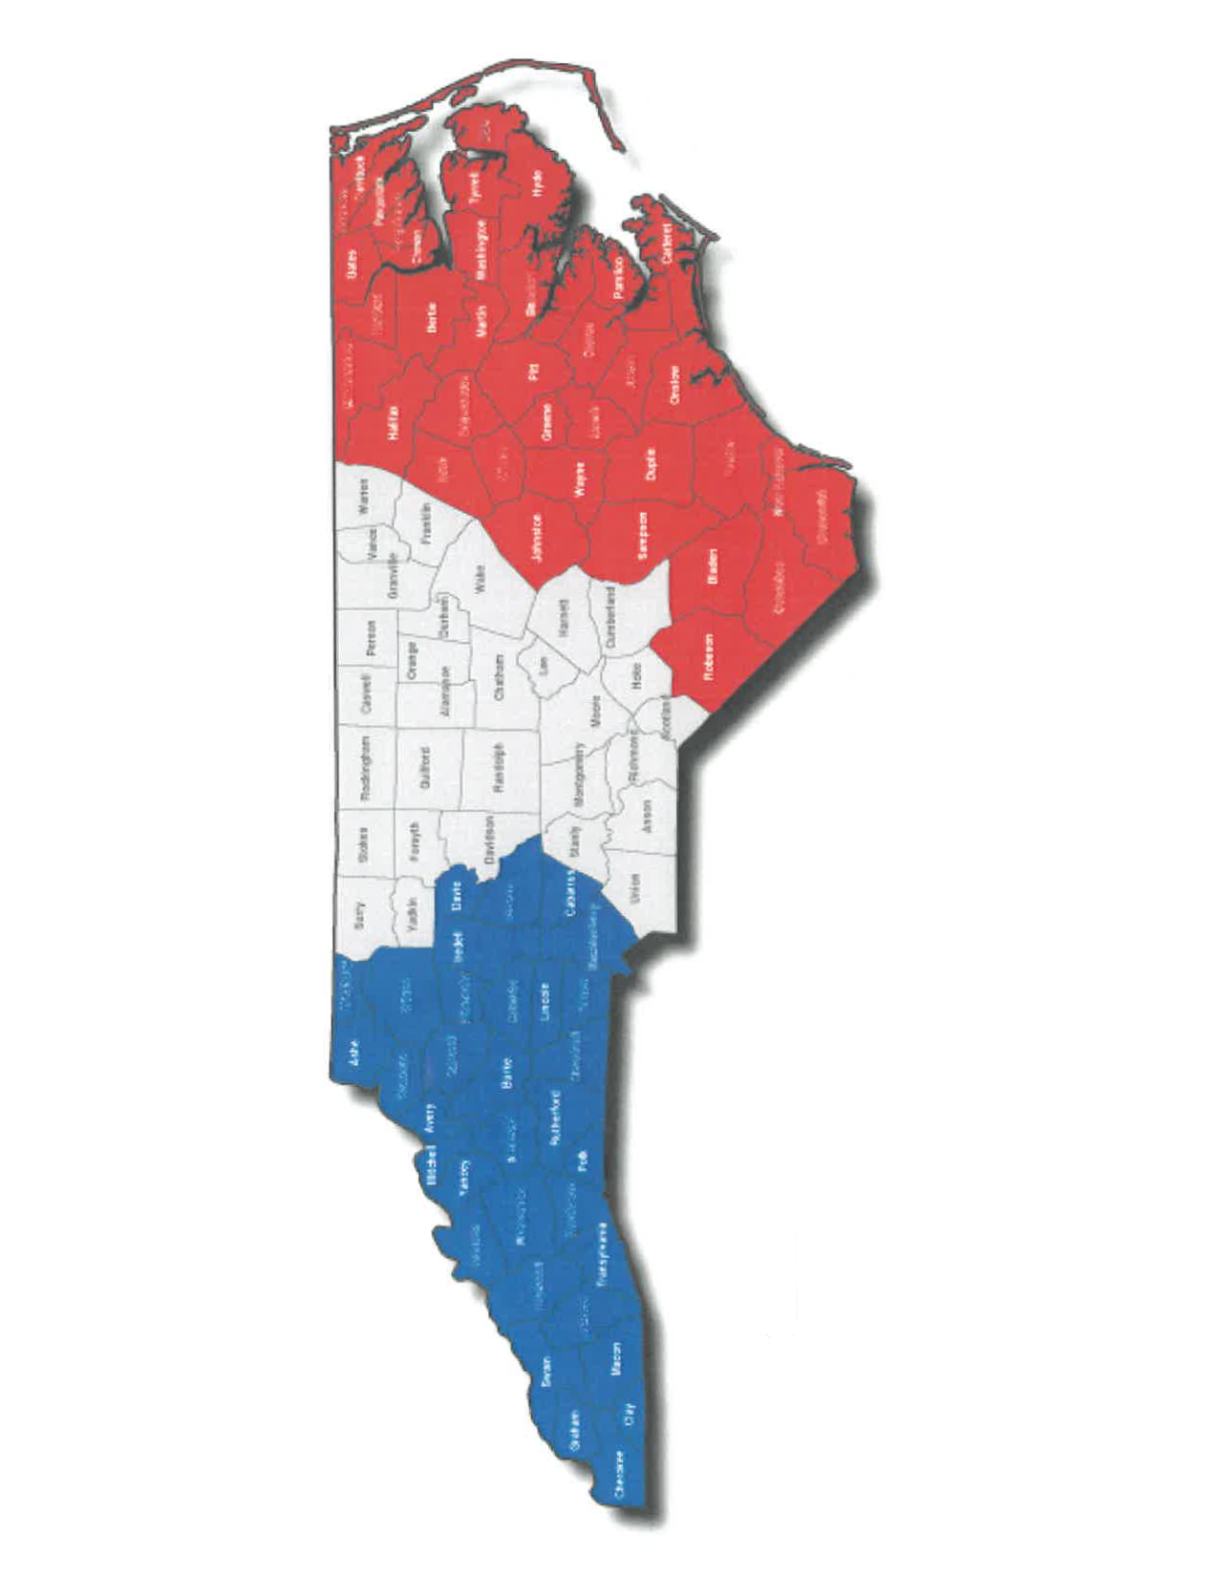
APPENDIX B

